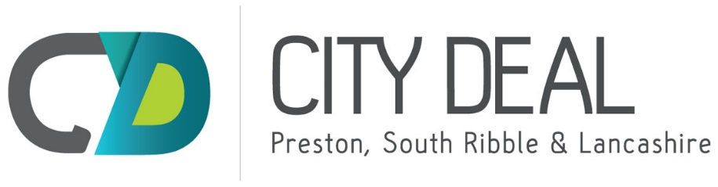

City Deal Executive and Stewardship Board – 22nd June 2016
New Scheme approval and sign off process
(Appendix 'A' refers)

Report Author: Joanne Hudson – City Deal, Lancashire County Council, 01772 534179, email joanne.hudson@lancashire.gov.uk

Purpose of the Report
To set out proposed improved arrangements to enable the Executive and Stewardship Board (CDE&SB) to consider and approve any new/additional schemes prior to inclusion in the Business and Delivery Plan.
Recommendation
That the proposed new scheme approval process and template be approved and used for all new City Deal Schemes and the process be reviewed in 12 months time.
Background
The CDE&SB approved a number of revenue schemes, to be funded from the IDF in 2015. The IDF is, in overall terms, a balanced fund with anticipated income already allocated for spend on approved schemes, it is nonetheless important that the CDE&SB remain open to the inclusion of new schemes, subject to the availability of funding. It is therefore proposed that the process for including any new potential schemes be managed through an agreed approach that enables the CDE&SB to make investment decisions, based on a set of criteria such as; contribution to the City Deal objectives and core outputs; availability of funding and the relationship to existing projects in the programme.
Current Position
The City Deal Business and Delivery Plan is approved annually by the E&SB and sets out the full range of City Deal schemes and activities to be delivered. The schemes described in the plan are approved 'in principle' within a funding envelope, subject to final design and budget approval from the City Deal Infrastructure Delivery Steering Group (IDSG).
It is possible for new schemes to emerge mid-year and in order to avoid a situation where schemes are delayed until the next business planning stage, the need for a new process of approval has been identified. This will allow the E&SB to consider and approve new schemes as they emerge. The process designed to facilitate this is described below and a template (attached) has been produced to capture all the scheme information necessary.

The proposed new scheme approval process is as follows:
- The 'new scheme' template should be completed by project manager/scheme lead in order to capture all relevant scheme information including an estimate of cost and timescales.
- The completed forms should be submitted to the City Deal Programme Management Team with any supporting information.
- The City Deal Programme Management Team will circulate the templates and supporting information to a nominated lead from each City Deal partner who will coordinate responses from their organisation and make recommendations on the scheme.
- The Programme Management Team will compile responses and recommendations into a summary document for consideration by the City Deal Project Team and then Programme Board, who will similarly make recommendations prior to final approval/otherwise by the E&SB. (Depending upon the scheme type, views will be sought from IDSG members, e.g. where technical views are required in relation to deliverability).
- Project leads will be informed of the final decision.
- Where a scheme has been rejected then reasons will be provided, where schemes are approved this would be in principle and prior to any work commencing on site, final design and cost approval would need to be secured from IDSG.
- Once a scheme has been approved, a scheme profile/template will be created for the City Deal Business and Delivery Plan and milestones will be agreed.

